Running head: PRIOR ODOR EXPERIENCE ENHANCES TASTE-ODOR ASSOCIATION LEARNING DEPENDING ON MODALITY 1

Prior odor experience enhances taste-odor association learning depending on modality

Thomas R Gray*1*, Isaac Goldstein*1* & Donald B Katz*1,2,3*

*1* Graduate Program in Neuroscience, Brandeis University, Massachusetts, 02453, Waltham

*2* Volen Center for Complex Systems, Brandeis University, Massachusetts, 02453, Waltham

*3*Department of Psychology, Brandeis University, Massachusetts, 02453, Waltham

**Abstract**

Olfactory experience drives many of the associations we develop for food and beverages. The influence of olfaction on eating is widely noted, however, the underpinnings of how exactly olfaction creates the associations is understudied. In fact, olfaction itself is more complicated than odors just entering the nose. Previous work has demonstrated that olfactory stimuli can be processed in two different modalities, retronasal (through the mouth) and orthonasal (through the nose). Though olfactory experience is conventionally thought of in terms of smelling things outside of the body, rats learn an odor-reward association preference learning task faster when the odor is retronasally experienced rather than orthonasally. Additionally, odors and taste when first experienced produce neophobia which disappears following repeated experiences with the stimuli. Given that innocuous pre-testing exposure to tastes reduces neophobia to novel tastes, we hypothesized that pre-exposure of olfactory experiences would similarly prevent neophobia to other odors and potentiate olfactory association learning. We hypothesized that this potentiation of odor association learning would be modality specific. Our study tests this hypothesis, examining the impact of olfactory exposure (OE) on subsequent olfactory preference learning (preference for an odor paired with sucrose) in rats. Our results demonstrate that rats trained after OE develop a significantly stronger preference for the paired odor than unexposed rats.

*Keywords:* Chemosensation, Multimodal, Lick Microstructure, Association Learning

**Introduction**

Taste-odor associations are critical for an animal’s survival. From birth to adulthood rats rely on crucial taste-odor associates to navigate their environment. Much work has been done on how taste-odor associations produce aversion to conditioned odors in taste-potentiated odor aversion (TPOA) tasks, however, parsing out how preferences develop over time remain somewhat elusive in terms of systems neuroscience. Recent research has shown roles of gustatory cortex (GC) involvement in TPOA in an odor modality specific manner. TPOA is thought to act through within-compound association, requiring GC, such that the perception

# Method

# Preregistration

# This study was not preregistered.

# Subjects

# A total of 40 adult, taste-naïve, female, Long-Evans rats from Charles River were subjects. All subjects were individually housed and kept on a 12/12 hr light/dark cycle. Experiments were conducted during the light cycle and complied with Brandeis University Institutional Animal Care and Use Committee guidelines.

# Behavioral Apparatus

# Rats were tested in a clean Brief Access Lickometer MED-DAV-160 (MedAssociates) at the same time everyday unless otherwise specified. Clean bottles and spouts were used for every experiment. A fan and vacuum near the access door was engaged during the retronasal only condition to eliminate emitted odors from the end of the lick spout.

# Behavioral Procedure

# Rats were first habituated to the apparatus for 5 days before the experiment. In the retronasal only condition habituation included the sound of the engaged fan and vacuum. Benign odor exposure was delivered orthonasally, retronasally, or in a combined fashion for a subset of animals for 120 hours until the 2nd day of habituation in the apparatus. During the second day of habituation all animals were restricted to 10-15mL of water per 24 hours and trained to lick from the bottle spout in the apparatus. After habituation, animals were given a preference test where they were given 60 seconds to lick from a pseudorandom bottle containing one of two odors dissolved in distilled water at 0.01% v/v or water alone. Once licked, the animal had 5 seconds to lick from the spout. This was repeated for 60 trials every 30 seconds. In the orthonasal only condition these odors were rubbed on the outside of the spout past the reach of the animal’s tongue. After the initial preference test, animals were trained on an AB/AB/AB, BA/BA/BA, A/B/A/B/A/B, or B/A/B/A/B/A protocol were A days had an odor paired with 200mM sucrose and B days had an odor paired with distilled water. Then, animals performed a post-training preference test in the same fashion as the initial test. For every stimulus type there were two bottles for baseline correction, internal control, and the detection of delivery errors. In a subset of animals, a second day of preference testing was performed.

# Stimuli

# Odor test stimuli were typical examples of odorants used in olfactory experiments (www.sigm aaldrich.com), >98% purity: 2-hexanone, butyl acetate, methyl valerate, carvone, ethyl butyrate, cis-hexen-1-ol, and citral in aqueous solution (0.01% v/v in distilled water). Paired taste stimuli [(www.fishersci.c](http://www.fishersci.c/)om) sucrose (200 mM) in distilled water. Odor pre-exposure was delivered in either the homecage drinking bottle, in cotton balls taped above the food tray, or in the homecage drinking bottle with a concentric vacuum preventing orthonasal olfaction.

# Measurement of Lick Bouts

# Bouts of licking were defined as rhythmic licks separated by 180ms and with more than 500ms without a lick. Lengths of bouts are also indicative of preference learning and as such we calculated not only the number of bouts but also the average length of those bouts over the pre-test and post-test sessions. Based on work looking at rapid attenuation of taste neophobia we determined that measurement of licks in the first bout was an appropriate proxy for rapid attenuation of neophobia to odors.

# Measurement of Preference

$$Preference Index(PI)= \frac{{\overline{X}}_{Paired LICKS}}{{\overline{X}}_{Paired LICKS}+ {\overline{X}}_{Unpaired LICKS}}$$

$$Change in Preference (∆PI)={PI}_{post}-{PI}_{pre}$$

# Measurement of Palatability

# We compared pre-test and post-test average licks to each solution in order to measure the palatability of paired and unpaired odors to plain water. This was done to bind the odor preference index by 0 and 1. The palatability score was then defined to be average licks to each odor relative to water such that the relative palatability of solution X was:

(1)

$$Palatability\left(X\right)= \frac{N_{LICKS }(X)}{N_{LICKS }(dH_{2}O)}$$

# where NLICKS (X) is the average number of licks to tastant X across both pre-test and post-test sessions and where X is each odor solution. NLICKS (dH2O) is the same and compared to itself to establish a baseline for both the pre-test and post-test sessions.

# Measurement of Discrimination

$$d^{'}=Z\left(\frac{{\overline{X}}_{LICKS}}{N_{Paired}}\right)-Z\left(\frac{{\overline{X}}_{LICKS}}{N_{Unpaired}}\right)$$

# Statistical Tests

# Results

# The observed difference in preference, as indicated by the difference in average lick counts per trial, between odors associated with sucrose and those unpaired with sucrose, reveals a significant increase in average licks per trial for both enriched and unenriched cohorts (p=0.03 and p=0.01). The enriched cohorts displayed a less significant difference in preference compared to the unenriched counterparts, contrary to our initial hypothesis. Additionally, subjects subjected to an equivalent number of training sessions over a condensed period of 3 days, as opposed to the standard 6-day training period, did not develop a significantly discriminable preference for either odor (p=0.38).

# Upon analyzing the change in preference pre-test and post-test sessions, a significant increase in the change of average licks per trial was exclusively seen within the enriched group (p=0.01). The results suggest that the duration of the training period and olfactory pre-exposure may influence the expression of odor preference in a complicated way, with there being no difference in the establishment of a preference but instead for how strongly that preference develops from pre-test to post-test.

# Discussion

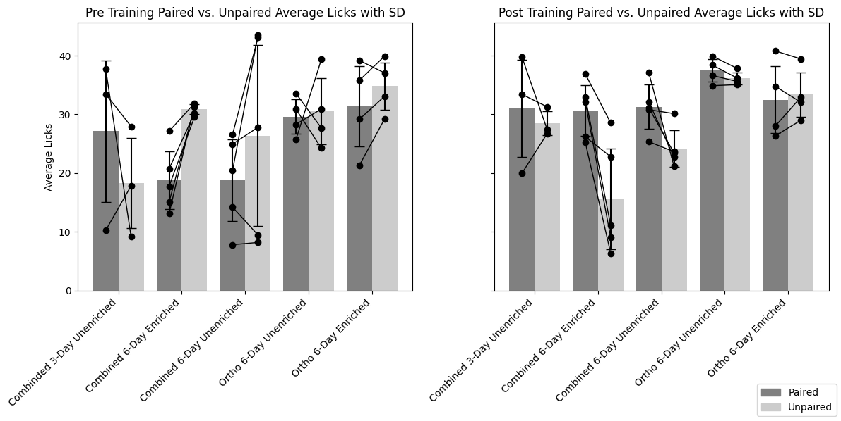

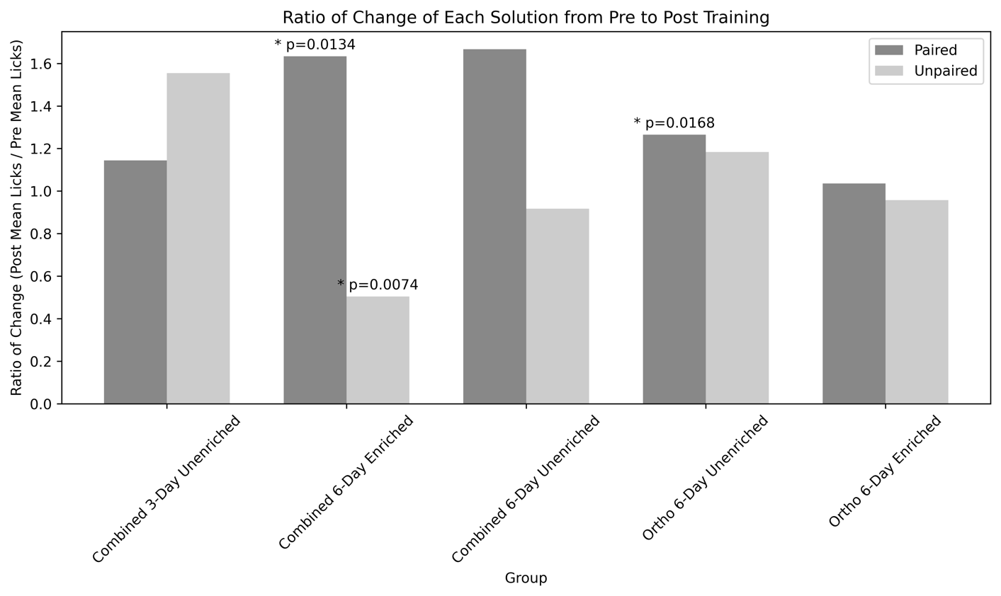

# What is the total training exposure to the odors?

# Are there any differences in participation in trials in the preference tests?

# Measuring Discrimination of Odors

# Measuring Preference of Solutions

# Measuring Palatability of Solutions

# Measuring Change of Licking Patterns over time

# Measuring Latency to Lick

# What do other papers use to define learning?